RT NO:214,dt:18/12/2013
Telephone No. 0866 2455614
Fax: 0866 2452102
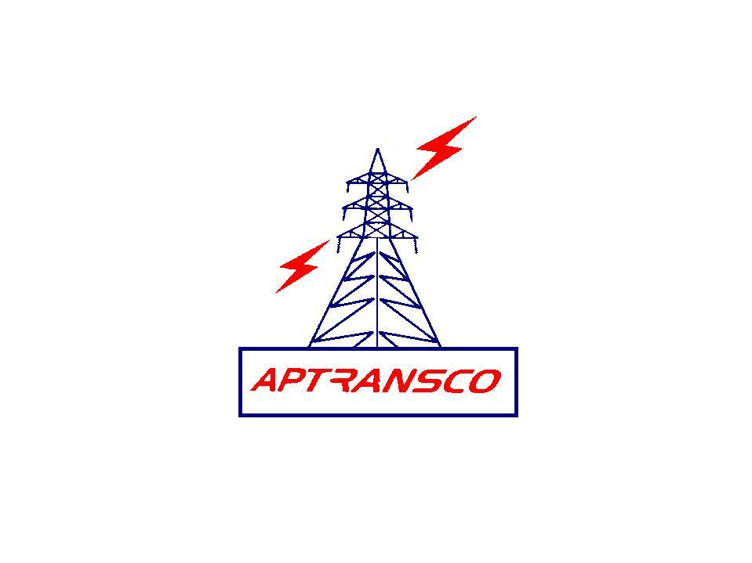

TRANSMISSION CORPORATION OF ANDHRA PRADESH LIMITED

LOCAL PURCHASE ORDER IN DUPLICATE

From To
The Chief Engineer, M/s. Dubas engineering Pvt Ltd.,
Zone, A.P.TRANSCO # 9-1-89/1, 1st Floor,
Gunadala, Beside Sangeet Theatre, S.D Road,
Vijayawada Secunderabad - 500 003.
Ph: 040 – 27894409/ 4419
Fax: 040-2789 4409

LPO.No.CE/Zone/VJA/Tech/AE /LPO.No. 30/13-14/D.No. 1301/13, dt. 17-12-13
Sir,
Sub:- A.P.TRANSCO- Zone, Vijayawada- Supply of spares for “Dubas” 220V battery Charger for utilization at 132KV substation Brahmadevam - Detailed purchase order – Issued - Reg

Ref:- 1. Lr.No.SE/TL&SS/NLR/Tech/ADE/AE-3/F/D.No.1666/13,dt.23.11.13
2. Your Ref: CSS/S3-HYD/0013/Dubas/2013,dt.07.11.2013
* * *
I, acting for and on behalf of Transmission Corporation of Andhra Pradesh Limited (herein after called the A.P.TRANSCO) accept your offer dt.07.11.2013 cited in the above reference for supply of spares for “Dubas” 220V battery Charger for utilization at 132KV substation Brahmadevam of the above cited correspondence and subject to the terms and conditions setout in the order.
- SCOPE OF SUPPLY: This contract relates to the supply of materials as detailed in clause.2 below.

- SCHEDULE OF MATERIAL AND PRICES:

Sl.  No. | Description | Qty | Rate  Rs Ps | Unit | Amount  Rs Ps
1 | Sensing transformer 0-415, 0-6 | 3 Nos. | 2025.00 | Each | 6075.00
2 | Pulse transformer 0-415, 21-0-21 | 2 Nos. | 2025.00 | Each | 4050.00
3 | DC Capacitors 3300mfd/ 350V DC | 4 Nos. | 4050.00 | Each | 16200.00
4 | Fuse fail card – DU 110079 | 2 Nos. | 1350.00 | Each | 2700.00
5 | Earth fault card DU 110021A | 1 No. | 1687.00 | Each | 1687.00
6 | Charger card- DU 110014A | 1 No. | 11000.00 | Each | 11000.00
 | Sub-Total-I |  |  |  | 41712.00
 | Add: Excise duty on Sub- Total-I |  |  |  | 5155.60
 | Sub-Total-II |  |  |  | 46867.60
 | Add: VAT @5% on Sub-Total-II |  |  |  | 2343.38
 | Add: Transportation charges on Sub-Total-II |  |  |  | 1500.00
 | TOTAL |  |  |  | 50710.98
(Rupees Fifty thousand seven hundred ten and paise ninety eight only)

- PRICES: The prices indicated in clause.2 above are firm and for delivery F.O.R TLC stores, Ongole and are not subject to any variation on any grounds. The prices are inclusive of excise duty, VAT & Freight charges as mentioned in Clause No. 2 the freight charges will be reimbursed based on the production of proof payment.

- TRANSIT INSURANCE: The materials shall be duly insured by you and you are responsible for settlement of insurance claims and replacement of lost/ damaged / short supplied materials.

- SALES TAX: VAT @5% included in clause No: 2. The A.P.TRANSCO TIN No. 28760127045

- EXCISE DUTY: The prices indicated in clause No.2. above are exclusive of excise duty which will be paid extra as applicable. Present rate of excise duty 12.36%.
You shall furnish the following certificate with the invoice
‘Certified that the Excise duty claimed in the invoice is adjusted in the personal ledger account maintained by the Central Excise Department on “. You shall also agree that if at any time, any central excise duty reported to have been paid by you, has not been paid or a lesser amount has been paid by you shall refund such amounts irrespective of time. Any benefit due to MODAVT scheme shall be passed on the A.P.TRANSCO.

- DELIVERY: The proforma invoice shall be submitted with in one week from the date of receipt of this purchase order and the materials described in clause No.2 shall be dispatched within 4 weeks from the date of confirmation of readiness of cheque from the Superintending Engineer/ TL&SS/ Nellore.

Any variation up or down in sales tax or other statutory levies or new levies introduced by the Government after placing of this purchase order shall be to A.P.TRANSCO’s account.

Provided that in cases where the delivery schedule is not adhered to by you and there are increases in excise duty or sales tax or other statutory levies of new imposts after the agreed delivery dates, you shall bear the impact of these levies and if there is downward variations /revision the A.P.TRANSCO shall be given credit to that extent.

You are also requested to dispatch the materials only on receipt of confirmation of readiness of cheque from the Superintending Engineer/ TL&SS/ Nellore.

- PENALTY: In case of delay in delivery of materials, whatever may be the reason, penalty at the rate of ½% per week or part thereof subject to a maximum of 10% of the purchase order value will be levied.

- TERMS OF PAYMENT:
90% payment will be made against delivery and remaining 10% will be paid after installation. The proforma invoice in triplicate may be submitted immediately to Superintending Engineer/ TL&SS/ Nellore and Superintending Engineer/TLC/ Vijayawada on receipt of purchase order. The material may be dispatched after hearing the confirmation of readiness of cheque.

- DESPATCH INSTRUCTIONS: The materials as per clause No. (2) Shall be consigned to the Asst. Executive Engineer/ TLC/ SD-I/ Ongole and dispatched by Road to the consignee as indicated in clause no. (3).

All original documents shall be sent to the Superintending Engineer/ TL&SS/ Nellore for arranging payment. Copies of invoices shall be marked to the Superintending Engineer/ TLC/ Vijayawada.

A Photostat copy of the L.R shall be sent one each to the Superintending Engineer/ TL&SS/ Nellore and the Asst. Executive Engineer/ TLC/ SD-I/ Ongole immediately after dispatched through any reputed transporting contractors.

- PERFORMANCE GUARANTEE: The spares/ equipment offered by you are guaranteed against manufacturing defects, for materials quality and workmanship, for proper fitment to the original equipment and for satisfactory performance for a period of 12 months from the date of putting them into service or 18 months from the date of dispatch whichever is earlier. You shall be liable to make good any defects that may develop in the materials/ spares due to faulty designs, unsound materials or bad workmanship provided always that such defective parts are not repairable at site and are not in the mean time essential in commercial use of the sub-station/ lines are promptly returned to your works unless otherwise arranged.
- TESTS AND TEST CERTIFICATES: Test conforming to latest editions of relevant ISS shall be conducted and test certificates furnished directly to the Superintending Engineer………………………….. for according approval.

- PACKING: All the materials shall be securely packed in such a manner as to withstand rough handling during transport up to site. All the above materials shall be adequately protected before dispatch to prevent damage, corrosion and entrance of foreign matter.

- SECURITY DEPOSIT: Waived.

- LOSS OR DAMAGE: External damages or shortages that are prima facia, the result of rough handling in transit or due to defective packing will be intimated to you within a fortnight of receipt of the materials. Internal defects/ damages or shortages of any internal parts which can not ordinarily be detected on a superficial visual examination though due to bad handling in transit or defective packing or other reasons would be intimated within two months from the date of receipt of materials. In either case, the defective or damaged materials shall be replaced and shortages made good by you, free of cost to the Board.

- CORRESPONDENCE:

  - Your acknowledgement of receipt of this order and all correspondence of general or technical nature shall be addressed to this office.

  - All correspondence regarding dispatch, payments etc., shall be addressed to the Superintending Engineer/ TL&SS/ Nellore with copies marked to this office.

- JURISDICTION: All and any disputes or differences arising out of or touching this order shall be decided by courts or tribunals situated in Vijayawada. No suit or other legal proceedings shall be instituted elsewhere.

- ACKNOWLEDGEMENT: Please acknowledge the receipt of this order with your confirmation of its acceptance. The additional copy enclosed may please be returned with your signature in token of your acceptance.

Yours faithfully

CHIEF ENGINEER
APTRANSCO
VIJAYAWADA ZONE
We accept the terms and conditions of this order.
SIGNATURE OF THE SUPPLIER

Copy transmitted to the Chief Engineer/ Transmission/ Vidyut Soudha/ Hyderabad

Copy forwarded to: -
The Divisional Engineer / TL&SS/ Nellore
The Executive Engineer/TLC/ Ongole
The Superintending Engineer/TLC/Vijayawada
The Superintending Engineer/TL&SS/ Nellore

The Asst Divisional Engineer/O&M., O/o the Chief Engineer/ Zone/ Vijayawada

/tmp/in/input.doc

